**OBJECT DATA INQUIRY**

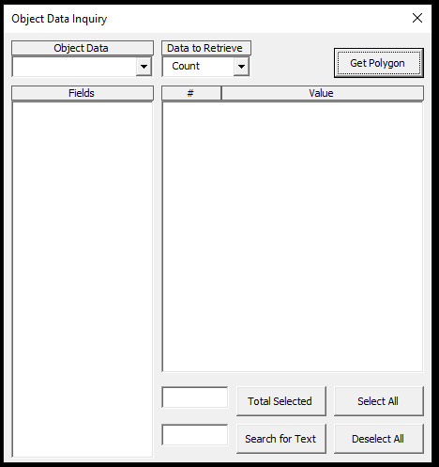

Object Data is a list of all the Object Data tables in the drawing. Once you select one, all the table fields are displayed in the Fields listbox. Select the one you want to Inquiry. There are two ways to collect the data: Count and Amount. Use Count if you just need to know the number of the different field values. Use Amount if you need to total another field for each of the different field values.

You need to have a polygon (closed polyline) around the objects you want to collect the data ready before starting this program.

We will go through an example of each way to collect data:

Count to get customers

Amount to get cable lengths

**Count to get Customers:**

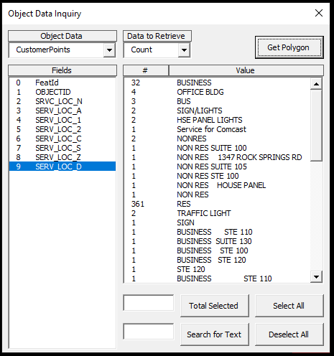

In this example, I did the following. With different data and/or table names the process will be the same but what is selected will be different.

Select “CustomerPoints” in the Object Data list

Select “9 SERV_LOC_D” in the Fields list

Select “Count” in the Data to Receive list

Click on Get Polygon

You can remove any item on the Value list by selecting it and hitting the Delete key.

You can also select multiple items of the list and get a total of those numbers. You click on what you want to select and click it again to deselect it. You do not need to hold the Shift key or the Ctrl key. You can also search for text and have it select the items with the text within it. Let’s find the businesses from the above example. Type “bus” in the textbox left of the Search for Text button and then click the button. It is not case sensitive so “bus” and “BUS” will find the same items. That returns 56. Let’s also search for “office”. Up to 60 now. “mall” makes it go to 64. Search the list for other text that you know are business. Remember to click Total Selected to update the total.

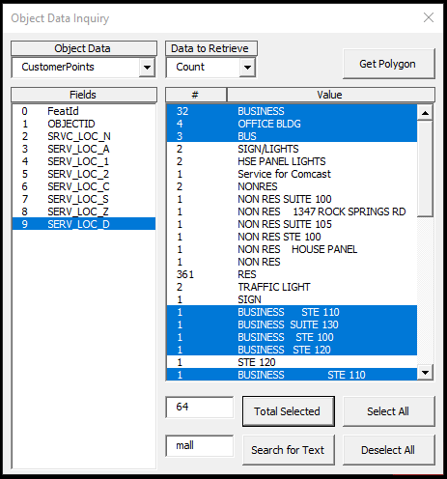

**Amount to get cable lengths:**

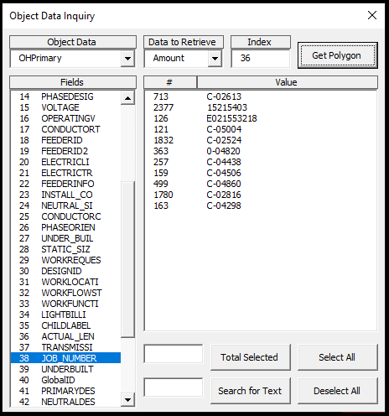

In this example, I did the following. With different data and/or table names the process will be the same but what is selected will be different.

Select “OHPrimary” in the Object Data list.

Select “38 JOB_NUMBER” in the Fields list.

Select “Amount” in the Data to Receive list. Doing this makes the Index textbox appear.

Type “36” in the Index textbox. This is to add the ACTUAL_LEN field.

Click on Get Polygon.

You can remove any item on the Value list by selecting it and hitting the Delete key.

To get the total length of all these items, click Select All then Total Selected.

